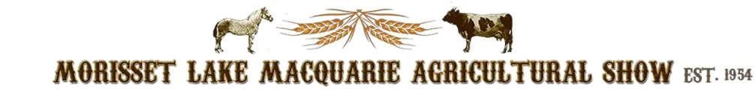
PO BOX 2 Morisset NSW 2264
President – Justin Rumore Secretary Rebecca O’Brien Treasurer – Glynis Newberry

APPLICATION FOR STALL HOLDERS 21st & 22nd October 2023

Email: justinkerrin@yahoo.com.au
Call: 0419252698

Saturday 21st 9am till 9pm
Sunday 22nd 9am till 4pm

Price for 2 days $250.00

Enclosed Fee $………….……or Direct Debit amount, details below $.......................................................

Name ………………………………………………………………………….…………….…………...….

Address……………………………………………………………………………….………...…………...

Phone……………………………………...Mobile……………………………………….……………......

Email address………………………………………………………………………….………….………...

Please print

Type of stall………………………………………………Power required YES NO

For commercial/business stall holders, a copy of your current insurance for a minimum $20M public liability cover must be included with this application.

Direct Debit details
BSB 637000
ACC No 721016269
ACC Name - Morisset L M Agricultural Show
Reference - Your name
Or post Cheque to above address.

Insurance Declaration:

- For Business/Commercial Stallholders: Defined as those who are a commercial enterprise and have an ABN. These stallholders must have their own insurance policy with a minimum $20M Public Liability cover and provide a copy of their certificate of currency to the Show. They cannot access the Show’s public liability insurance in any manner.

- For Hobbyist Stallholders: Defined as those who are not running a formal commercial enterprise nor have an ABN and they earn under $20,000 per year from their stall activity. Those Hobbyist Stallholders who meet this definition and have signed the below declaration are automatically covered under the Show’s insurance cover for Public Liability. The ASC’s Public Liability insurance does not extend to Hobbyists in any manner for any Products Liability exposure.

I declare that I am a Hobbyist Stall Holder, do not have an ABN and do not earn more than $20,000 in this enterprise on an annual basis. I am therefore protected under the Show’s Liability policy for Public Liability only. I am aware that this protection does not extend to Products Liability.

Signature: _________________________ Date: ___________________

